The Prediction of Career Peak, Length and Points

Leyan Yu
New York University
yuleyan526@gmail.com

Presented at: SIBR 2023 (Tokyo) Conference on Interdisciplinary
Business and Economics Research, 5th-6th January 2023, Tokyo, Japan

ABSTRACT
This paper focuses on building models to predict the career peak of young players, including some discussion of relation between peak year and draft number, career length and draft number as well as the analysis on first trade. Career peak refers to the year when a player scores the most during his whole career in NBA. The models are based on the database from https://www.sports-reference.com/. Models I have in the paper include model for peak year, model for peak year points and model for career length. Analysis is based on these models, including the discussion of the focus on superstars, the increasing career length, and most importantly, the prediction of career peak of young players. In my research, I found each increase in the draft number decreases the expected peak year by 0.014 years. That is, the higher the draft number, the later the peak year. The relation of peak year points, draft number and peak year is that: each increase in the peak year and draft number decreases peak year points by 0.206. In 1978, each increase in the draft number decreases the career length by 0.046 years; In 1983, each increase in the draft number decreases the career length by 0.056 years; In 1988, each increase in the draft number decreases the career length by 0.138 years; In 1993, each increase in the draft number decreases the career length by 0.173 years; In 1998, each increase in the draft number decreases the career length by 0.169 years. If we put any specific number into the formulae, which will be mentioned below, we can see a general increasing trend of career length. Since team managers care about whether each player is still valuable in his team, this research may help them to make decisions. They may decide to trade the player or keep him in the team after prediction, in order to make more profits for the team.

BODY
Introduction
Aging---a biological process characterized by cell deterioration, followed by loss of tissue function (Sousa-Victor P et al., 2015), and is generally related to some chronic diseases (Kennedy BK et al., 2014). Unfortunately, it is an inevitable problem faced by all basketball players. The players are always retired when they are too old to perform well in the team.

A decrease in performance of players that is relatively linear from the age of the peak until their 60 years old, afterwards, age losses are much more over the next 30-year period than at former times. (B. W. Young et al., 2005). The decline is easier to be observed with the following statistics. For the 100 m race, athletes’ performance declined from 2% to 9% between their ages of 35 and 45 years. At age 50 years, performance declined more---12.5% for men and 19% for women. (Lynda B. Ransdel et al. ,2009). The focus on career peak is more than this. The present results showed that senior top-level athletes reached on average their personal best performance later than the others. Although this trend was both observable in male and female athletes, the effect was more pronounced in females. It is possible to state that the career length of athletes is a key factor for reaching high performance levels.

Athletes involved in specialized training and competitions programs when they were young, are more likely to reach their peak at a relatively younger age than their peers; this supports the idea that delaying specialization could be a better way to reach elite senior success. Elite performance requires many hours of training and joining a large variety of competitions; thus, it is obvious that the longer the career gives a higher possibility to reach a better performance. Unfortunately, an athlete’s career can be finished due to many reasons: injuries, lack of motivation, and lack of performance improvements, which are all likely to reduce the chances of success. Therefore, the lack of reaching high level performance may become both the cause and the effect of an early career termination. In addition, the peak usually occurs quite a few years after the athletes reach their biological maturity. Previous studies on world-prominent athletes found that athletes, in the field of sprint and hurdles disciplines, reached their peak performance between 24 and 26 years of age, and around 26-28 years for throwing disciplines. (Gennaro Boccia et al.)

From former studies we know that the decline in performances for athletes always occurs accompanying with aging and how good they are in their peak performances is related to various factors. But how could we know exactly when an individual player reaches his peak in his career and at what age such decline could happen? We would figure this out in my paper. My study mainly focuses on the change in performances for NBA players from the beginning of their career and predicts the career peak of young players.

The prediction of career peaks gives managers a sense when their players will perform the best they can. Thus, they can determine whether it is worth paying the money to players, waiting for their peaks. If they find the peak year will come too late and it will never be worthy to pay such large amount of money, they can trade players, which may potentially create more values for the whole team. This concern may become more important when talking about superstars. Superstars requires more resources to better show their talent and skills. So the money cost may be much more on them. The prediction of career peak of superstars can help managers to measure the spent on training superstars as well as the potential benefits they may produce when they reach their peak.

To see this in a broader view, not only for sports, the prediction of peak years may also be helpful to other businesses. The prediction of individual can be done in a similar way based on the performances of people in past years in that business. Thus, we can also know when a person will perform the best and decide whether we should trade him. Similarly, if the cost of training a person will create more profits, it is worth doing so; if it is not, or for those who are old and have already past their peak years, it may not be worth doing.

Method
Peak year refers to the year that the player scores the most during his whole career. I get all the data I need from https://www.sports-reference.com/. Firstly, I choose 50 NBA players who have retired and all played many years in the league(≥7 years) to get data of their draft number and peak years. The data has a high variety. I choose players randomly, including the ones played in past years and more recent years as well as different, random draft numbers. For example, Phil Hubbard, draft number 15 in 1979, plays 12 years in NBA. He reaches his peak in season 1984-1985, his 8th year playing in the league. I have assembled all the data of needed fields in the table. (Table 1). Based on these data, I formed a linear regression model which relates the draft number and peak years together and shows how can we calculate the peak year from the input---draft numbers. Moreover, I also introduce PTS (points scored) into the model. The same example. I add the data of PTS, which is 15.8, in peak year for Phil Hubbard and do a further analysis. All the players I choose now have an extra data set which indicates the PTS they goal in their peak years. (Table 1). The following process is exactly the same. When I get the predicted peak for Rookies, I put the PTS into the model. Then I get another linear regression model, which includes all the element, to predict the PTS in peak years for chosen players. The three variables, draft number, peak year and PTS have mean value of 35.06, 5.86 and 15.42 with standard deviation of 26.08, 2.43 and 5.55 respectively. The linear regression models I found are as following: Peak year=α*(-0.01382) +6.34456, Points in peak years=β*(-0.09145) +α*(-0.11428) + 19.95844. α refers to the specific draft number of individual players and β is the peak year(indicated as a number, the βth year of the player’s career is his peak year). The two models I got then could be applied to Rookies with different draft numbers to predict when they would reach their career peak and how many points they would goal in peaks.
During my research, I found that career length is also an interesting factor to talk about because it is related to the career peak. So I get linear regression models for career length every five-year interval, from 1978 to 1998, to see how does it change as draft number changes, and as time goes by. These models I obtained are as following: Career length = -0.04590*α+7.67173(1978), Career length = -0.05601*α+8.74314(1983), Career length = -0.13772*α+11.50415(1988), Career length = -0.17253*α+11.36525(1993), Career length = -0.16895*α+12.80369(1998). α still refers to the specific draft number of individual players. Each model contains all the players who are in draft pick in that year. The trend is found between draft numbers and number of years in careers.

Name | Draft number | Peak year | PTS in peak years
Rick Robey | 3 | 3 | 12.4
Micheal Ray Richardson | 4 | 9 | 17.9
Reggie Theus | 9 | 5 | 23.8
Clemon Johnson | 44 | 6 | 9.7
Marc Iavaroni | 55 | 5 | 6.7
Jim Paxson | 12 | 4 | 21.7
Phil Hubbard | 15 | 8 | 15.8
Sly Williams | 21 | 3 | 13.9
Edgar Jones | 31 | 6 | 10.2
Clint Richardson | 36 | 7 | 9.7
David Robinson | 1 | 5 | 29.8
Kevin Gamble | 63 | 4 | 15.6
Chris Dudley | 75 | 6 | 7.1
Hersey Hawkins | 6 | 3 | 22.1
Rod Strickland | 19 | 9 | 18.9
Scott Skiles | 22 | 5 | 17.2
Johnny Newman | 29 | 5 | 16.9
Jeff Hornacek | 46 | 6 | 20.1
Anthony Mason | 53 | 8 | 16.2
Doug West | 38 | 4 | 19.3
Purvis Short | 5 | 7 | 28.0
Maurice Cheeks | 36 | 9 | 15.6
Jeff Cook | 49 | 2 | 8.5
Pat Cummings | 59 | 6 | 15.8
Michael Cooper | 60 | 4 | 11.9
Sidney Moncrief | 5 | 4 | 22.5
James Bailey | 6 | 8 | 14.1
Earl Cureton | 58 | 6 | 8.6
James Donaldson | 73 | 4 | 11.8
Jerry Sichting | 82 | 4 | 11.5
Allen Leavell | 104 | 4 | 14.8
Mark Eaton | 107 | 3 | 9.7
Kiki Vandeweghe | 11 | 4 | 29.4
Larry Smith | 24 | 5 | 11.1
Rick Mahorn | 35 | 2 | 12.2
Jawann Oldham | 41 | 6 | 7.4
Kurt Nimphius | 47 | 7 | 12.0
Rory Sparrow | 75 | 4 | 12.6
Alton Lister | 21 | 6 | 11.6
Danny Ainge | 31 | 10 | 20.3
Frank Brickowski | 57 | 11 | 16.9
Terry Teagle | 16 | 10 | 16.1
Ricky Pierce | 18 | 8 | 23.0
Fred Roberts | 27 | 10 | 10.8
Rod Higgins | 31 | 10 | 15.5
Rick Fox | 24 | 6 | 15.4
Lucious Harris | 28 | 10 | 10.3
Tracy Murray | 18 | 6 | 16.2
Dikembe Mutombo | 4 | 1 | 16.6
Dee Brown | 19 | 5 | 15.6

Table 1 Player chosen with draft number, peak year and PTS in peak years

Results
The first formula I got is---peak year=α*(-0.01382) +6.34456. (Figure 1) The model formed which relates all three elements together is---points in peak years=β*(-0.09145) +α*(-0.11428) + 19.95844.

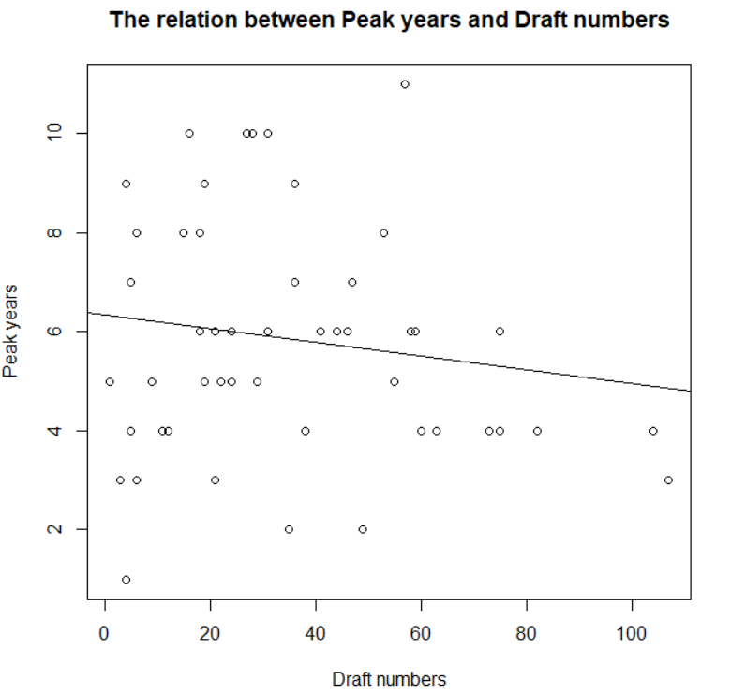
Figure 1 The plot of predicted linear trend of peak years and draft numbers

Here are the career length models I get: Career length = -0.04590*α+7.67173(1978), Career length = -0.05601*α+8.74314(1983), Career length = -0.13772*α+11.50415(1988), Career length = -0.17253*α+11.36525(1993), Career length = -0.16895*α+12.80369(1998). If we randomly choose a number for pick, for example 5, and apply to each model, we get a career length of 7.4, 8.5, 10.8, 10.5, 12.0. We could see a general increasing trend of career length.

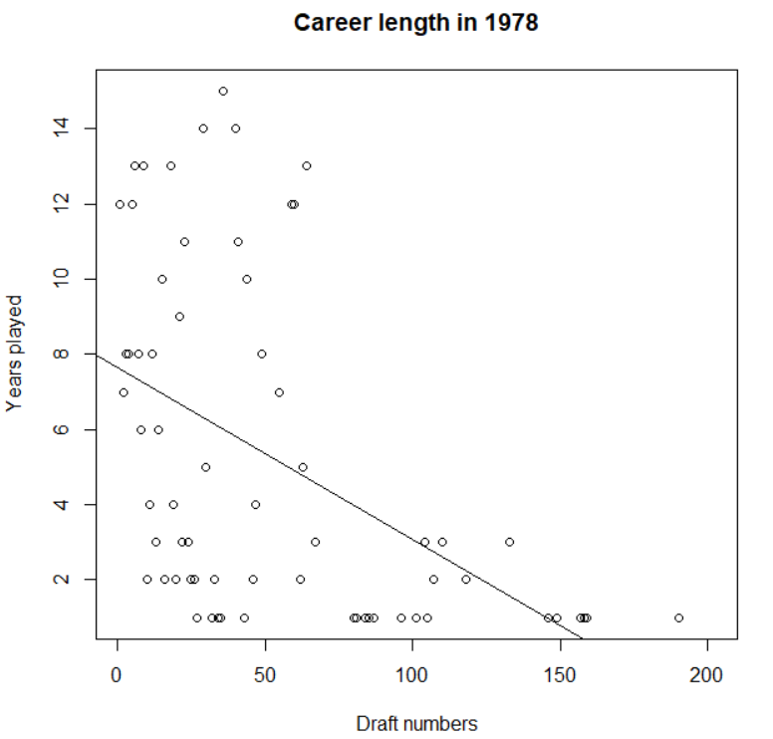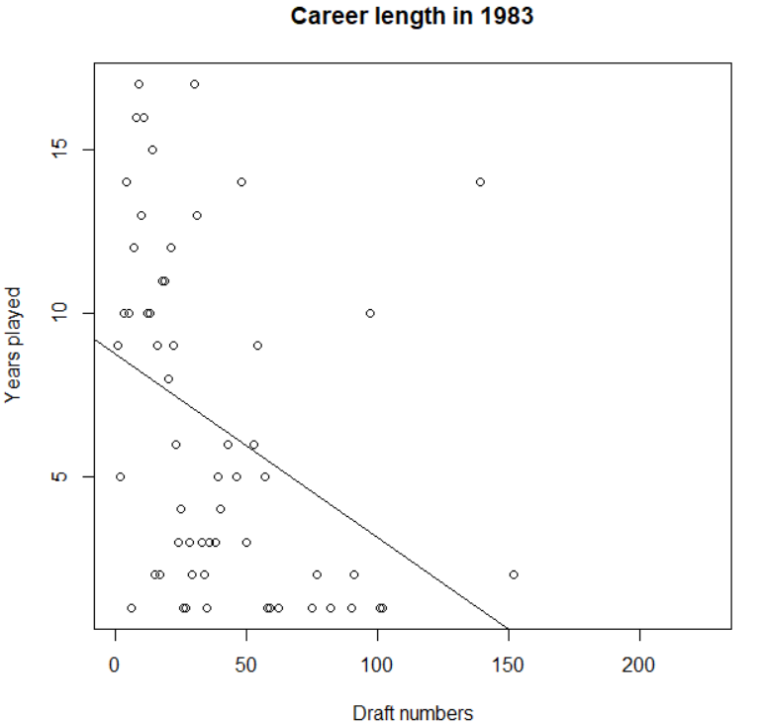
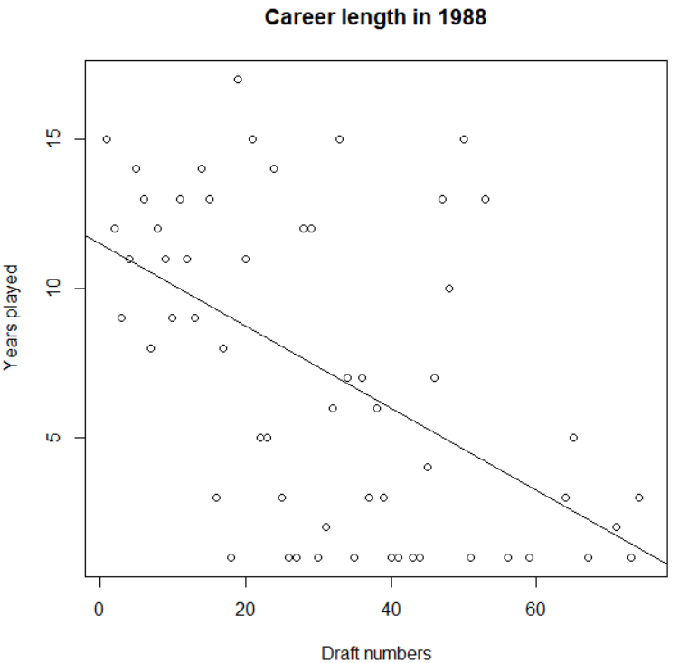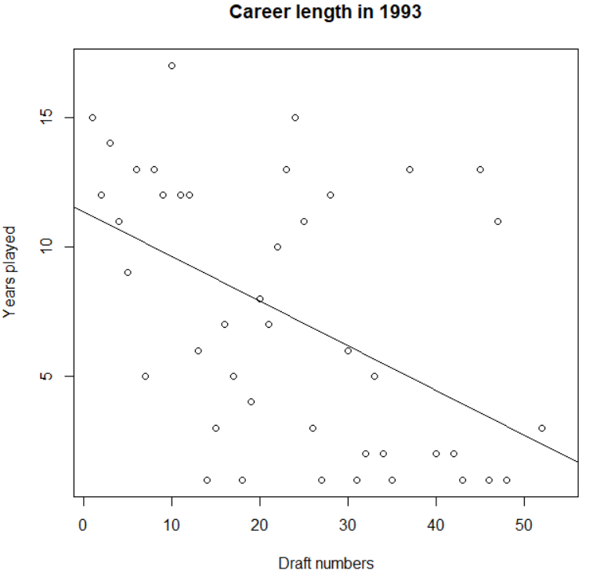

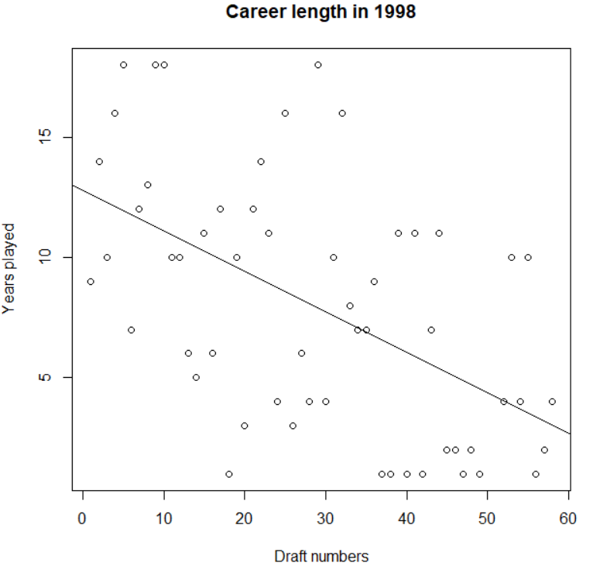

Figure 2 The relation between draft numbers and career length in 1978, 1983, 1988, 1993, 1998

I also found whether players are traded by the team before their career peak is interesting. We can see if the team manager is patient enough to wait their peaks. If the first trade year is before their peak year, it means the manager is not patient enough, they should hold the player longer to wait for the peak. Here is the table summarizing the results.

Name | First trade before peak year?
Rick Robey | Yes
Micheal Ray Richardson | Yes
Reggie Theus | No
Clemon Johnson | Yes
Marc Iavaroni | Yes
Jim Paxson | No
Phil Hubbard | Yes
Sly Williams | No
Edgar Jones | Yes
Clint Richardson | Yes
David Robinson | No
Kevin Gamble | Yes
Chris Dudley | Yes
Hersey Hawkins | No
Rod Strickland | Yes
Scott Skiles | Yes
Johnny Newman | Yes
Jeff Hornacek | Yes
Anthony Mason | Yes
Doug West | No
Purvis Short | No
Maurice Cheeks | No
Jeff Cook | No
Pat Cummings | Yes
Michael Cooper | No
Sidney Moncrief | No
James Bailey | Yes
Earl Cureton | Yes
James Donaldson | Yes
Jerry Sichting | No
Allen Leavell | No
Mark Eaton | No
Kiki Vandeweghe | No
Larry Smith | No
Rick Mahorn | No
Jawann Oldham | Yes
Kurt Nimphius | Yes
Rory Sparrow | Yes
Alton Lister | No
Danny Ainge | Yes
Frank Brickowski | Yes
Terry Teagle | Yes
Ricky Pierce | Yes
Fred Roberts | Yes
Rod Higgins | Yes
Rick Fox | No
Lucious Harris | Yes
Tracy Murray | Yes
Dikembe Mutombo | No
Dee Brown | No

Table 2 Whether the picked players have first trades before their peek years
Discussion
The models for career length I get indicate an increasing focus on the superstars from past to nowadays. The slope of each model, from 1978 to 1998, becomes more and more deep, which means from the first drafts to the ones with larger draft numbers, the career length decreases more and more sharply. In other words, those with worse draft numbers begin to quit the league much earlier than the past. This may because of the more resources are used to the ones with good draft numbers. Team managers begin to focus more on the superstars and train them more. But for those with larger draft numbers, they cannot stay in NBA so long because less resources are paid resulting in less scores, they are likely to gain in the match.

The increasing in career length may be due to the better training method. Players are trained in a more proper way, so they are less likely to get injured. The more developed medical technology may also be an important factor. When players get hurt, they can get a better medical treatment and recover faster. Plus, the healthier lifestyle may also help to increase the career length. More nutritious and organic food are available in the market so players can eat in a healthier way. This helps them maintain a good body.

There are 29 players are traded by their team before their peak year and the left 21 reached their peaks in the same team as they are picked in the draft. This shows most team managers are not patient enough to wait their peaks. In addition, for those with lower draft numbers, they are seldomly being traded by team managers before their peak years. This means team managers are confident with them, being willing to give them resources and wait for their peak years.

Managers can use my results to determine whether they should keep training a player. The larger the draft number, the faster the peak year comes. But the difference on this is quite small. For example, generally, the difference between the peak year of draft number 1 and draft number 100 is only 1.38 years. However, the potential value of draft number 1 is quite high. That is, though it may take longer time for the draft number 1 to reach his peak year, the waiting of, or the cost of this 1.38 year is worthy because he potentially brings much more value than a draft number 100 player. In addition, since superstars are now more and more being focused, team managers can spend more money to buy those with lower draft numbers. They will potentially create more values. They also play longer (may even be much longer in the future) than those with higher draft numbers so the risk of retiring in a short term is only a little.

Conclusion
I build several models based on the data collected from sports reference to analyze the peak years, the scores in peak years. Several graphs clearly show what is the model like. I also discuss some interesting things during my research, like the generally increasing trend of career length and the rising focus on the superstars.
My research is still limited. Future researchers could pay more attention on the analysis of the focus of superstars. I found that the nowadays team managers may spend more resources on those with good draft numbers than in the past. But is it really worth to only focus on these superstars? Does this action effectively increase the winning rate of the whole team? These are some questions waiting for answering in the future.

REFERENCES
Boccia, Gennaro, et al. "Elite national athletes reach their peak performance later than non-elite in sprints and throwing events." Journal of science and medicine in sport 22.3 (2019): 342-347.

Kennedy BK, Berger SL, Brunet A, Campisi J, Cuervo AM, Epel ES, Franceschi C, Lithgow GJ, Morimoto RI, Pessin JE, Rando TA, Richardson A, Schadt EE, Wyss-Coray T, Sierra F (2014) Geroscience: linking aging to chronic disease.

Ransdell, L. B., Vener, J., & Huberty, J. (2009). Masters athletes: an analysis of running, swimming and cycling performance by age and gender. Journal of Exercise Science & Fitness, 7(2), S61-S73.

Sousa-Victor P, Garcia-Prat L, Serrano AL, Perdiguero E, MunozCanoves P (2015) Muscle stem cell aging: regulation and rejuvenation. Trends Endocrinol Metabol 26(6):287–296.

Young, B. W., & Starkes, J. L. (2005). Career-span analyses of track performance: Longitudinal data present a more optimistic view of age-related performance decline. Experimental Aging Research, 31(1), 69-90.

